POSITION DESCRIPTION

Position Title | Trainee Dental Assistant
Award/Agreement | Victorian Stand-Alone Community Health Services (Health and Allied Services, Managers and Administrative Officers) Multiple Enterprise Agreement 2011-2015
Classification | Trainee Wage Level A dependant on experience
EFT | 1.0
Tenure | 12 months fixed term
Hours of work | 8 am to 4.30 pm – 38 hours per week
Program Area | Dental
Location | Bentleigh East
Reports to | Supervising Dental Assistant and the GM, Dental

VISION
Healthy People, Healthy Communities

PURPOSE
Understand and meet the health and well-being needs of the diverse community as a socially responsible business

VALUES
Respect
- Treating all clients, staff and the community with care, dignity and understanding
- Provide a supportive and safe work environment for all voluntary and paid staff

Responsiveness
- Meet the needs of our diverse community by providing services that are accessible and innovative

Accountability
- Deliver sustainable, quality services in an efficient and financially responsible manner to achieve health outcomes
- Provide these services professionally and to the highest ethical standards

Collaboration
- Work with clients, staff and external stakeholders to achieve our Mission

INTRODUCTION
Connect Health & Community is a registered Company Limited by Guarantee operating in a quality, accredited, not-for-profit environment and governed by a Board of Directors.

Connect Health & Community incorporate key service delivery and community programs for Community Health, Home and Community Care, Dental, Gambler’s Help Southern (GHS) and Volunteers and Community Connections.

Connect Health & Community employ approximately 160 staff with an operating budget of approximately $10 million. Connect Health & Community has approximately 250 dedicated volunteers who assist our organisation and community. The organisation’s strategic directions and organisational values are supported by our staff and volunteers and defined by behaviours, skills and attitudes.

Connect Health & Community is guided by the principles of the social model of health; holistic service provision; continuous quality improvement; community and consumer participation and the diverse social aspects of our community.

POSITION SUMMARY
Connect Health & Community operates a 7-chair dental clinic providing general, denture and emergency dental care. Connect Health & Community dental clinic is one of 53 agencies participating in the Victorian Community Dental Program. The Community Dental Program is a partnership between the State Government, Dental Health Services Victoria (DHSV) and 53 Community Agencies. The aim of the Community Dental Program is to improve oral health for all Victorians and to ensure the greater needs of disadvantaged groups are addressed.

The position will ensure the provision of high quality, effective and efficient dental services for patients by undertaking dental assistant duties consistent with established dental assisting standards.

The position will:
- provide chairside assistance;
- Prepare surgery for dental treatment with correct instruments and materials ready for use as directed by the clinician
- Record findings from the oral examination
- maintain established infection control standards in the clinical setting and throughout the entire dental clinic;
- maintain dental equipment, consumables and supplies in the dental surgery;
- undertake dental equipment decontamination and sterilisation in the sterilisation facility;
- seek guidance from more experienced colleagues and the Supervising Dental Assistant;
- adopt a team approach to the delivery of dental care;
- undertake relevant administrative duties

ROLE OBJECTIVE
Excellent customer focus, professionalism and an emphasis on teamwork in the dental surgery and within the entire dental program team are qualities associated with the position. Participation and involvement in dental program initiatives is expected of the position.

INTERNAL and EXTERNAL RELATIONSHIPS
Where appropriate, the Trainee Dental Assistant is expected to develop and maintain effective communication networks and working relationships both internally and with key external stakeholders.

Internal working relationships include:
- Dental team members
- Reception staff
- Primary Health team
- Corporate team
External working relationships include:
- Clients
- DHSV and RDHM
- Other community health centres
- Medical practitioners
- Dental laboratories

- Reports to: Supervisor, Dental Assistants and the General Manager Dental

POSITION SPECIFIC RESPONSIBILITIES

CLINICAL DUTIES
- Adopt a team approach in the assistance of the delivery of dental care and be cognisant of the respective needs and demands of the roles of the dental clinician.
- Provide chairside assistance to the dental clinician including dental charting and utilising the 4-handed dentistry format where appropriate.
- Prepare and provide equipment, instruments and dental consumables for each patient according to dental treatment.
- Ensure appropriate dispensing of dental consumables.
- Ensure correct chronological usage of dental consumables in the dental surgery and the dental storeroom.
- Ensure an adequate supply of dental equipment, consumables and supplies in the dental surgery.
- Ensure all pharmaceutical materials and dental materials are stored and maintained in accordance with CONNECT HEALTH & COMMUNITY policy.
- Advise the Senior Dental Assistant on equipment maintenance and instrument replacement needs in the dental surgery.
- Undertake infection control procedures (including waste and sharps disposal) in the dental surgery and throughout the entire dental clinic.
- Undertake dental equipment decontamination and sterilisation in the sterilisation facility.
- Provide mentorship and clinical support to less experienced dental assistants.
- Seek guidance from more experienced colleagues and the Supervising Dental Assistant.
- Assist the Supervising Dental Assistant to orientate and train new dental staff (including locum dentists, other dental clinicians, agency dental nurses and dental students) in infection control protocol and practices.
- Undertake dental health education and participate in dental health promotion activities.
- Assist the dental operator in client behaviour management where appropriate.

GENERAL
- Participate in the professional development review program for dental assistants.
- Participate in dental clinic staff meetings and other organised activities such as quality improvement programs.
- Contribute to the development and review of dental clinic policies consistent with organisational goals and values.
- Actively contribute to and promote safety, quality and improvements in the workplace
- Demonstrate a commitment to workplace health and safety (WH&S). Ensure that you do not put at risk the safety of yourself or others. Report all injuries, accidents, near misses and potential hazards on the appropriate form.
- Work collaboratively with both dental and other health professionals in developing a community participation approach to service delivery.
- Undertake continuing education and professional development, organisation funded and or self-sponsored.
- Undertake other duties as directed.

ORGANISATIONAL RESPONSIBILITIES
- Promote activities and programs in accordance with Connect Health & Community Vision and Purpose.
- Model and promote Connect Health & Community Values in the workplace
- Adhere to Connect Health & Community Code of Conduct, ensuring professional conduct is maintained at all times
- Comply with all legislative requirements relevant to the position
- Comply with policies, procedures, systems and processes of Connect Health & Community and other external stakeholders
- Intellectual Property remains the sole property of Connect Health & Community, unless otherwise authorised and confirmed in writing
- Undertake and promote safe work practices and procedures in accordance with Connect Health & Community Policy
- Ensure Equal Opportunity principles are followed
- Connect Health & Community are commitment to the safety and wellbeing of children and young people.

ORGANISATION CHART

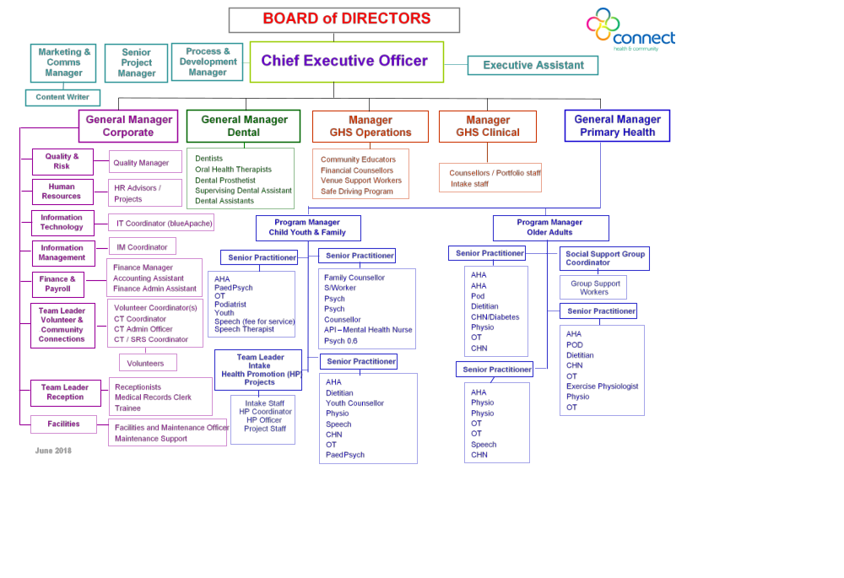
KEY SELECTION CRITERIA
Qualifications, Key Skills, Competencies and Personal Attributes

Mandatory
- As this is a traineeship position, prior experience in dentistry or nursing is not specifically required. The successful applicant will be required to undertake training for Certificate III in Dental Assisting at RMIT.
- Allocated study hours set by the Supervising Dental Assistant, trainee must use time to complete assignments/tasks set by RMIT.
- Demonstrated ability to work as a constructive team member.
- Excellent communication and interpersonal skills.
- A commitment to quality, client-focused care.
- Ability to work under pressure and be open and adaptive to change.
- Flexibility in task performance, work location (dental surgery) and hours of work.
- Commitment to continuing education and professional development, organisation funded or self-sponsored.
- Basic Computer skills

Desirable
- Understanding of dental public health principles.
- Ability to speak relevant second language and understanding of cross cultural issues.

OTHER REQUIREMENTS
- The successful applicant is required to provide a current National Police Check and Working with Children Check
- Hepatitis B Immunisation is a condition of employment for all CONNECT HEALTH & COMMUNITY staff that in the course of their work may be exposed to blood/bodily fluids or contaminated sharps. Proof of vaccination must be provided to your supervisor before you commence duty in this position.
PERFORMANCE APPRAISAL
A performance review shall be conducted 6 months after commencement of appointment and annually with the Supervising Dental Assistant or the General Manager Dental or his/her delegate.
Conditions of Employment
Remuneration: | - The employee will be paid in accordance with the Award/Agreement.  - Salary Packaging is available in accordance with prevailing legislation and Connect Health & Community Policy.
Location: | - Staff may be required to work at any Connect Health & Community (or partner) site.
Hours of Duty/Flexibility | - It is the intention that program and/or service coverage is provided across the span of Connect Health & Community operating times, however, staff may be required to work outside of CONNECT HEALTH & COMMUNITY business hours as requested.  - It is also our intention to offer staff flexibility in relation to hours and days of work.
Probationary Period: | - Confirmation of new employees to Connect Health & Community is subject to a 6 month probationary period, during which time the employee must demonstrate satisfactory capability to perform the Key Tasks and Accountabilities.
Pre-employment Checks | - Employment is contingent upon a satisfactory Police Check & Working with Children Check (as applicable)  - All employees of Connect Health & Community must be either an Australian Citizen, Permanent Resident or have an appropriate Australian visa that will legally enable them to fulfil the obligations of the contract of employment.  - Relevant prior service must be disclosed to Connect Health & Community.
Pre-Existing Injury/Illness: | - Applicants are required to sign a Pre-Employment Declaration Form.
General: | - Management, in consultation with the staff member, reserves the right to modify this position description as required.  - Connect Health & Community requires declarations and personal information relevant to employment. The collection and handling of this information will be consistent with the requirements of the Information Privacy Act 2000
Approval Date: | 2018
Revised Date: | 9/2/2016; 29/11/16; 06/09/18
Written By: | GM Dental
Authorised: | CEO
Acknowledgement:
Employee Declaration: | I have read, understand and acknowledge the contents of this position description.
Employee Name:
Employee Signature:
Date:

